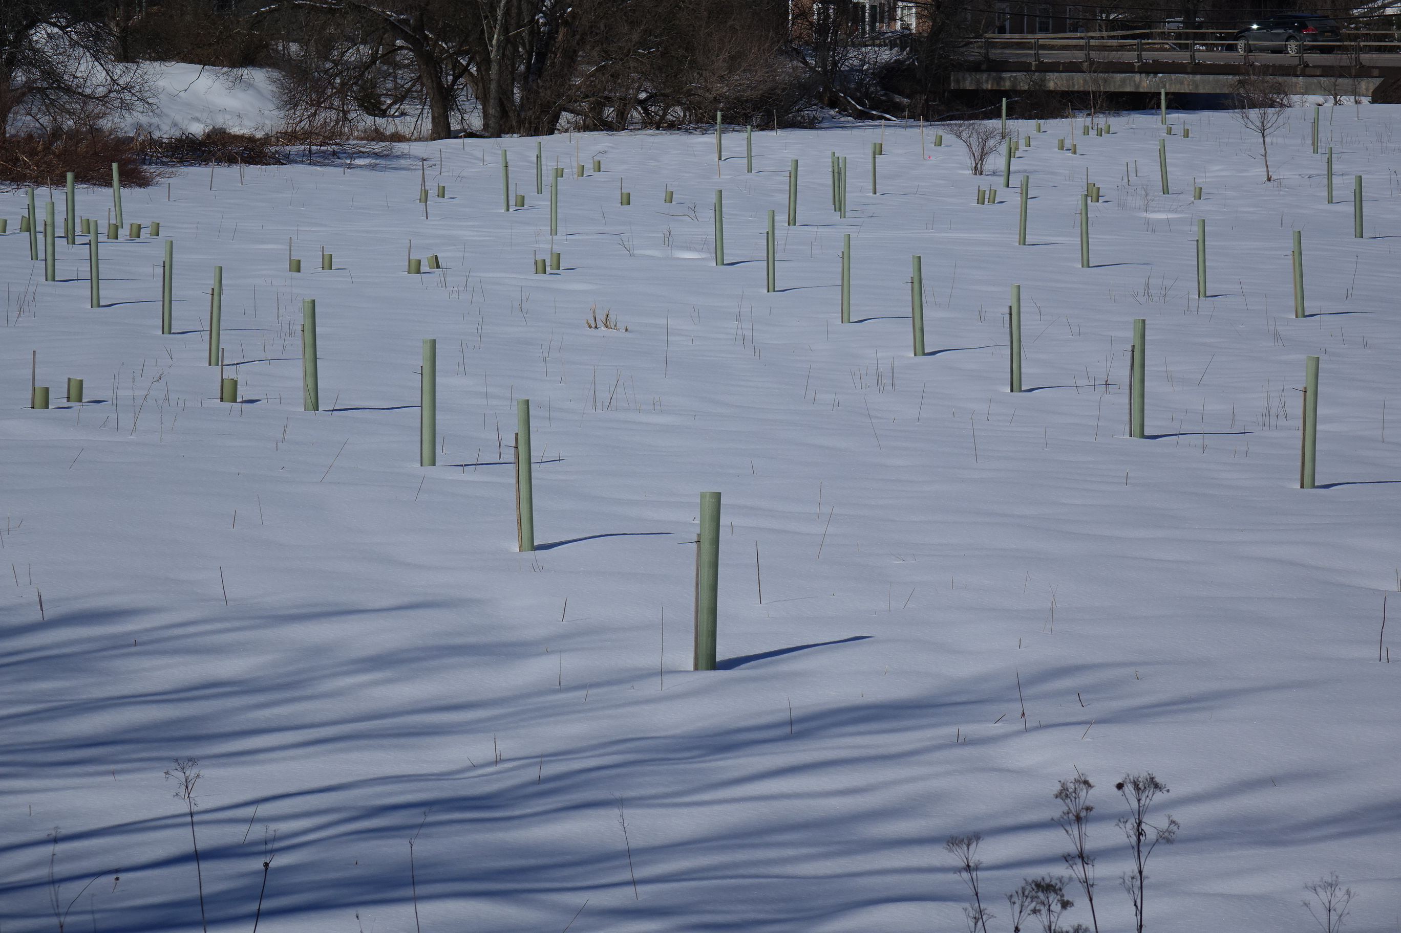
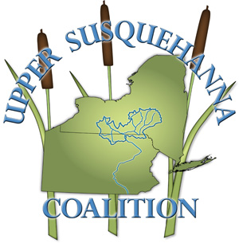
MYSTERY TUBES
ALONG
THE BUTTERNUT:
Why We Plant Thousands
of Trees Each Year


and

Join us for an online presentation about the tubes Wed. Mar. 24 7 PM
Link to Butternut Valley Alliance Event with details for joining the online meeting. Or use
https://tinyurl.com/3hxuy5bd

